Configure vSphere Replication

Select VM—right click—All vSphere Replication Action—Configure Replication

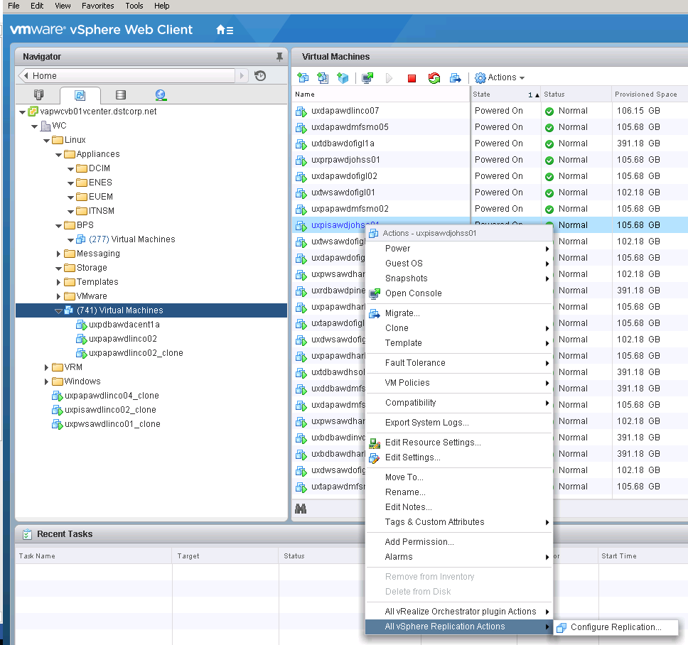

Select Replicated to a vCenter Server

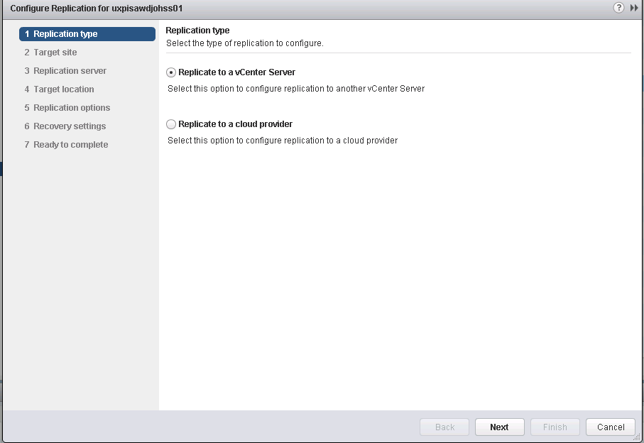

Select Target Site (here vapwcvb02vcenter is my target for vapwcvb01vcenter’s VM)

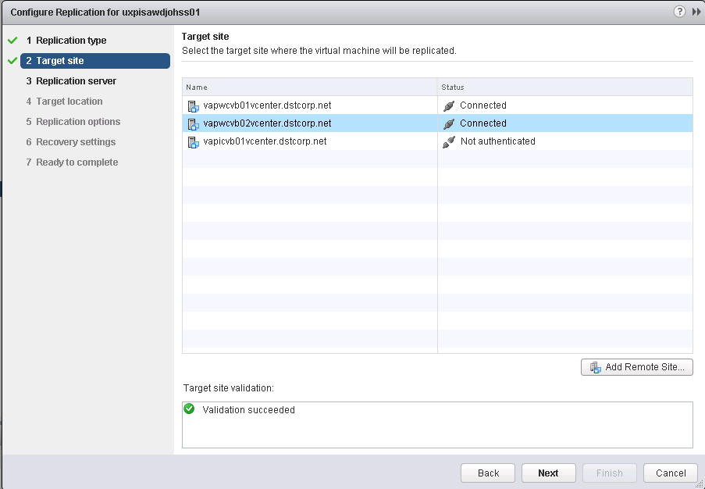

Select Replication Server (you can take Auto-Assign)

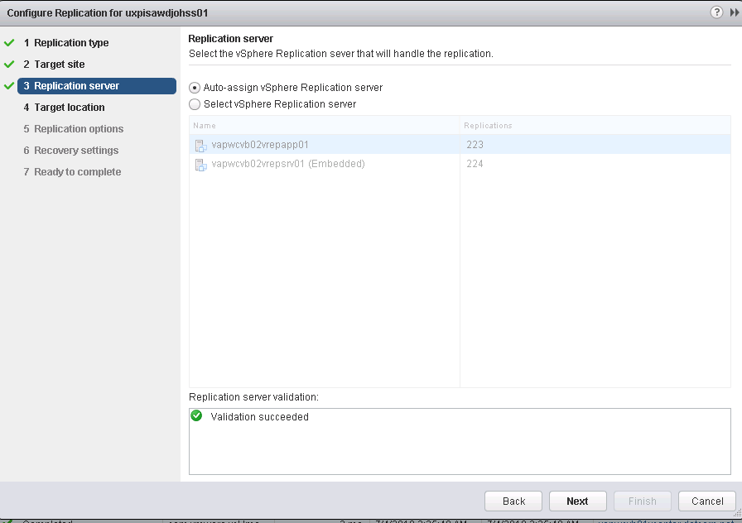

In Target Location click on edit select Data Stores cluster and LUN click Ok

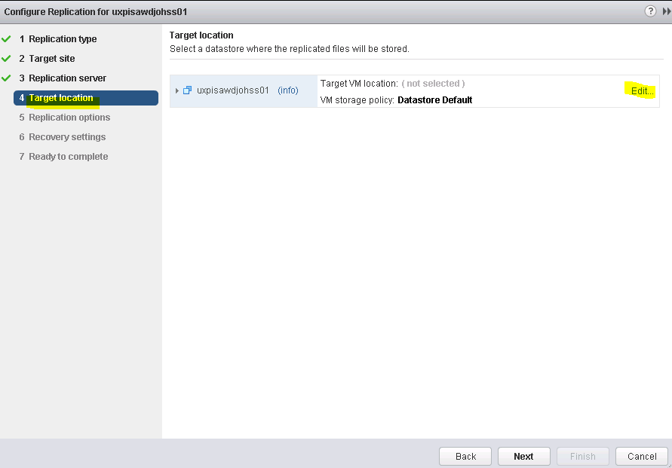

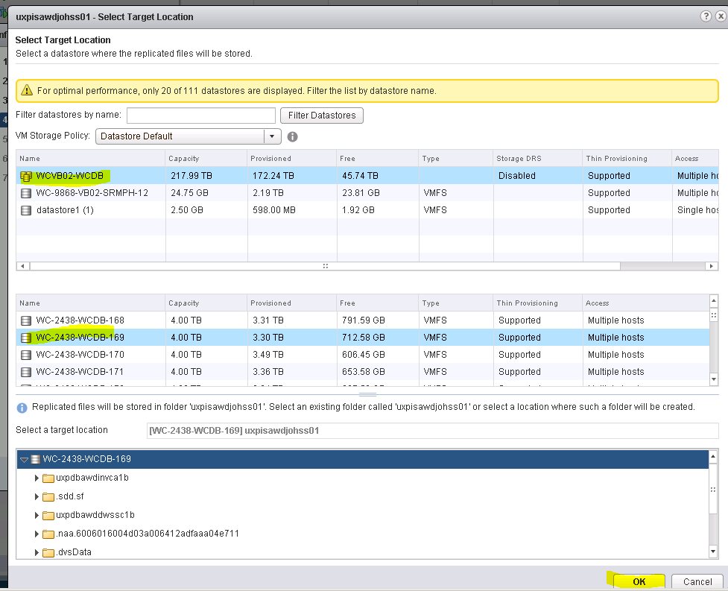

Now Verify Target VM location and click next

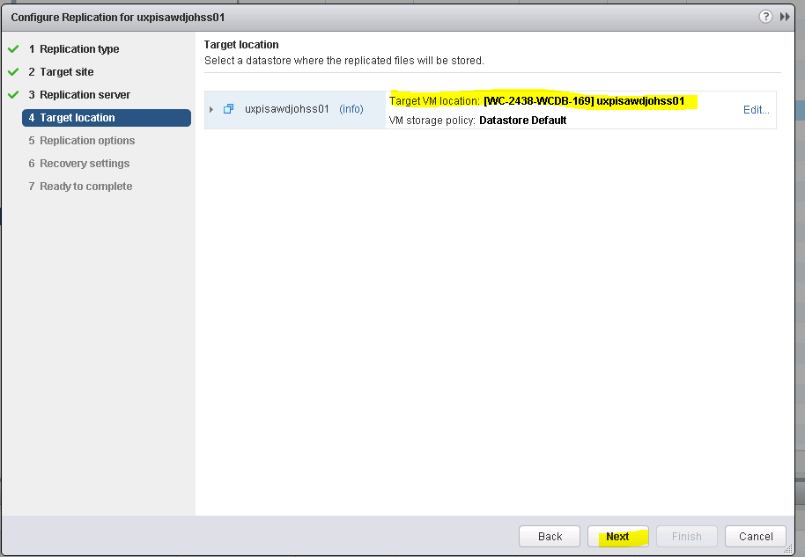

Replication Options leave it default click next

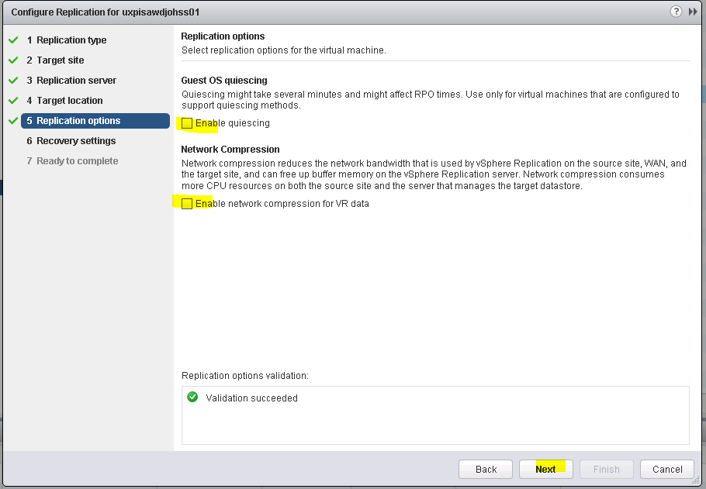

Set Recovery Settings to 15mins. This mean VM will try to sync to target site for every 15mins

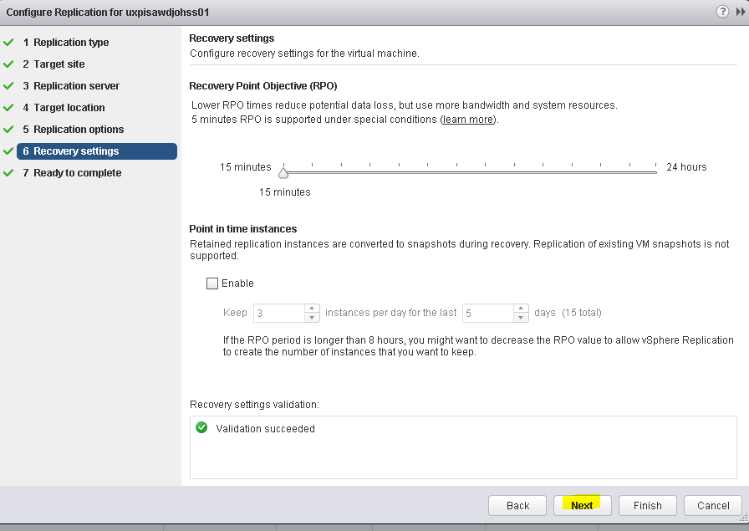

Go to ready to complete and click finish

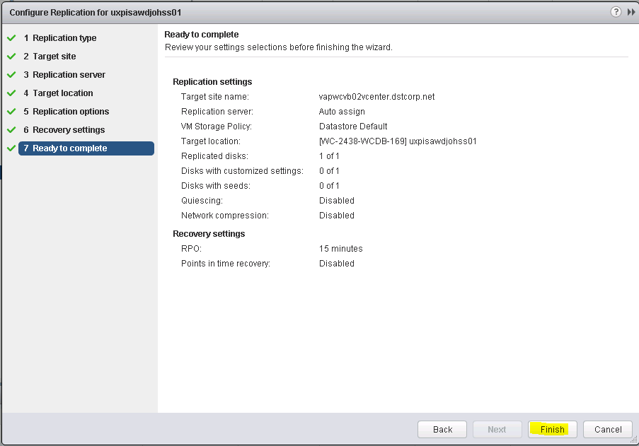

Once it finish.

Whenever you want to recover your replicated VM follow below process:

Select Vcenter—monitor tab

vSphere Replication—Incoming Replications—select VM which you want to power on from DR site.

It should show the status OK and make a not Last instance sync point time. If it showing old better to rysync for latest.

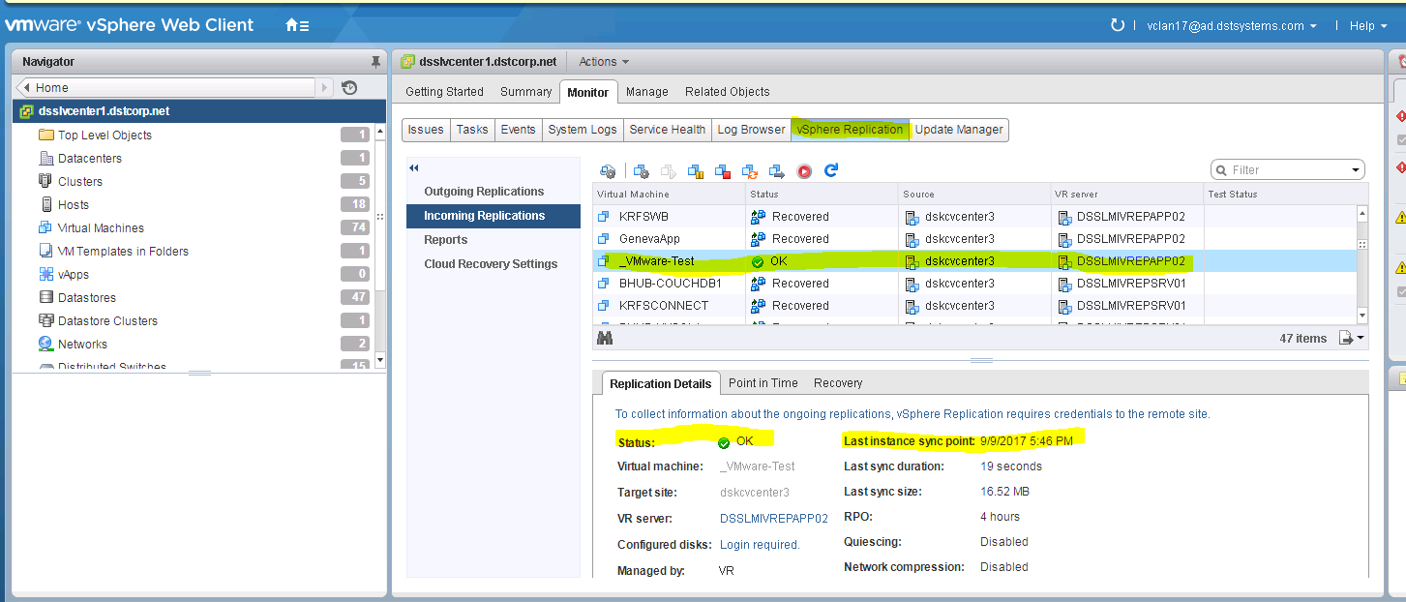

Right click VM

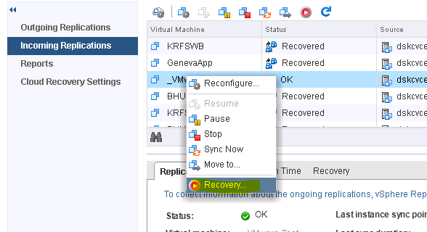

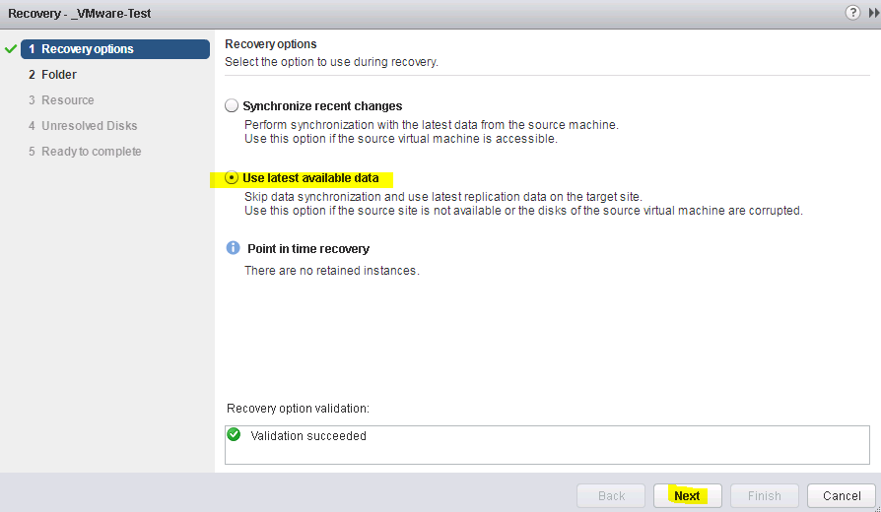

Select folder as per OS Linux or Windows

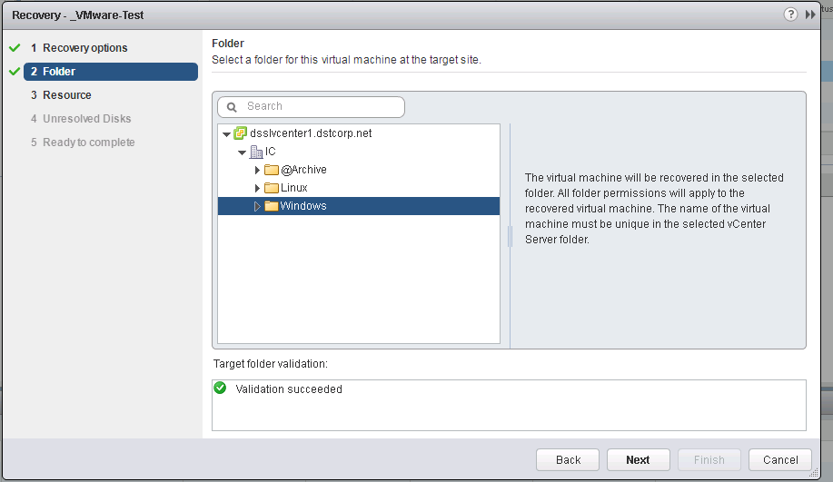

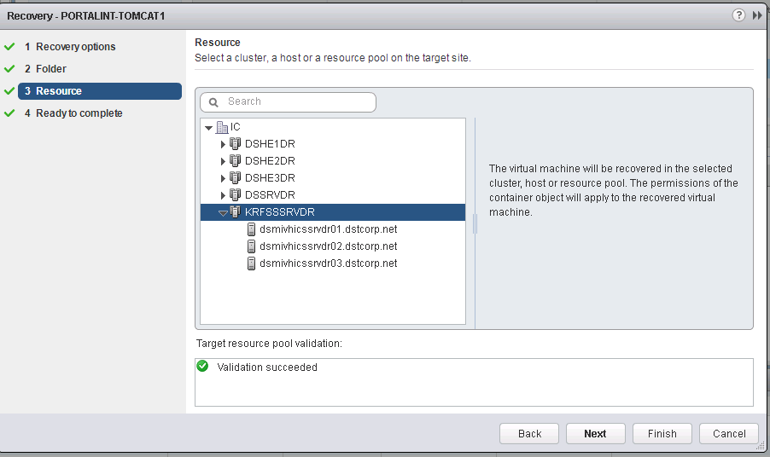

Finish it off and power on

